Aaron Snyderburn

Professor Adams

STA 147

1. 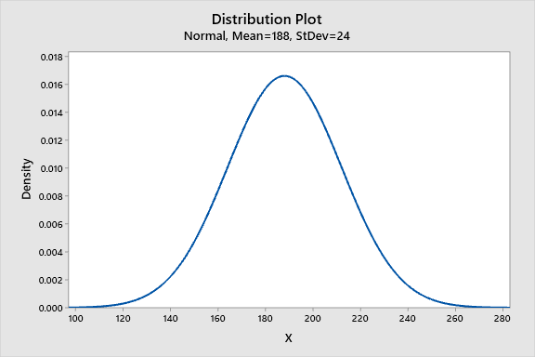
2. 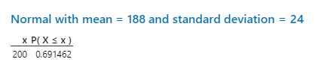
3. 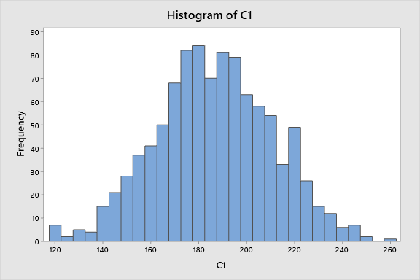

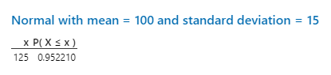 The probability is .95221

b. 